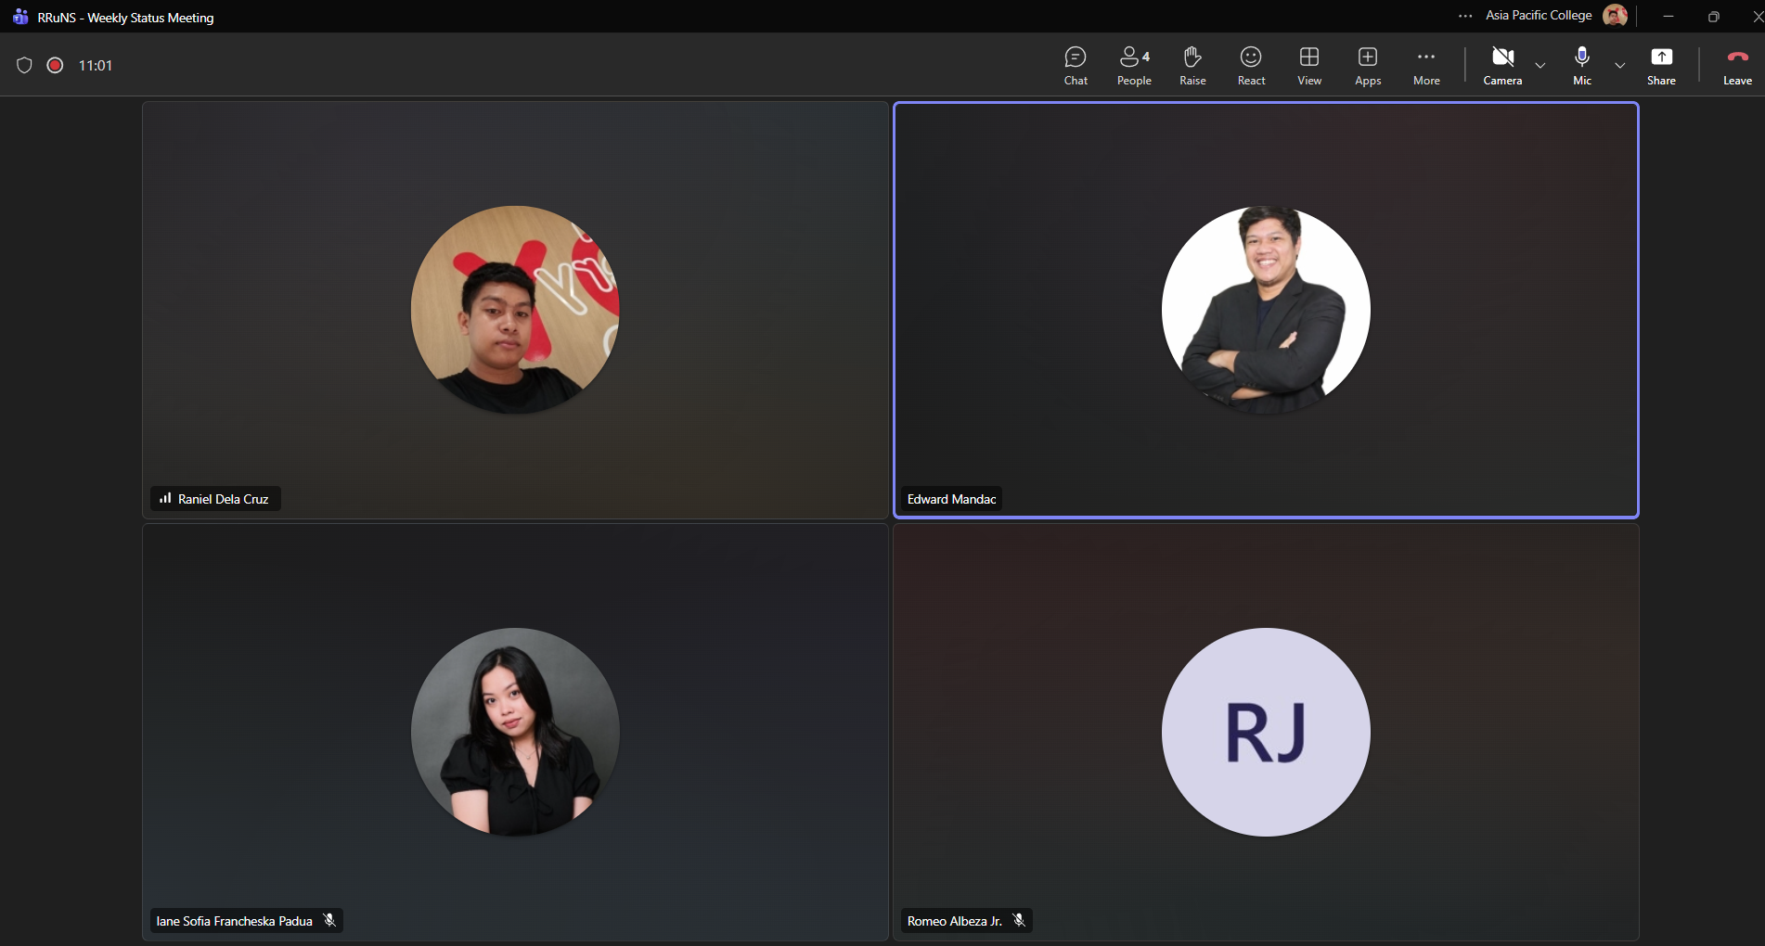
Weekly Status Report: Minutes of Meeting
- Date: Monday, October 19, 2026
- Meeting Called By: RRuNS Team
- Facilitator: Edward Mandac
- Link of the Meeting: Recap: RRuNS - Weekly Status Meeting Monday, 19 October | Meeting | Microsoft Teams

1. Attendees
- Romeo Jr. Albeza
- Iane Sofia Francheska Padua
- Raniel Q. Dela Cruz
2. Agenda
- Finalize the requirements
- Advice for defense
- Check the activity diagram and UCD (Use Case Diagram)
3. Summary
- Status update for the week:
  - The team focused on finalizing all remaining project requirements to ensure complete alignment ahead of upcoming milestones.
  - Received and discussed valuable advice, recommendations, and preparation tips from the adviser regarding the upcoming defense.
  - Conducted a thorough review and checking of both the activity diagram and the use case diagram (UCD) to ensure accuracy and consistency with system workflows.
- Blockers/Obstacle that encountered this week:
  - Ensuring final polish and precision across all system diagrams and project requirements in preparation for the defense evaluation.

